**Azure Cosmos DB – Table API**

**Step 1:** Open Microsoft Azure Portal

<https://portal.azure.com/>

**Step 2:** Click on **+New -> Databases -> Azure Cosmos DB**

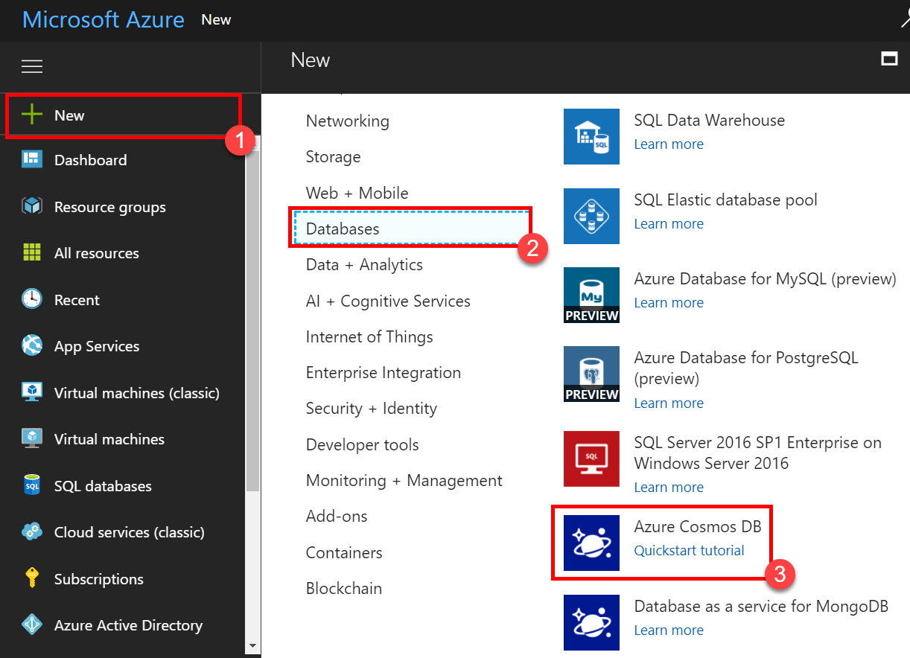

**Step 3:** Enter Account Details

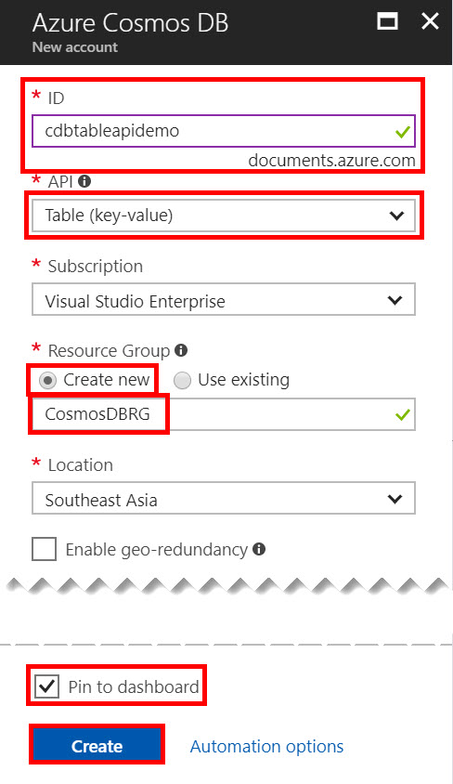

**ID:** Enter CosmosDB ID

Ex.cdbtableapidemo

**API:** Table (key-value)

**Subscription:** Choose any working Subscription

**Resource Group:** Create or Use Existing Ex. Create new: CosmosDBRG

**Location:** Choose nearest region

**Step 4:** Wait for few minutes to configure Cosmos DB.

Select **Overview** option & click on **+Add Table**.

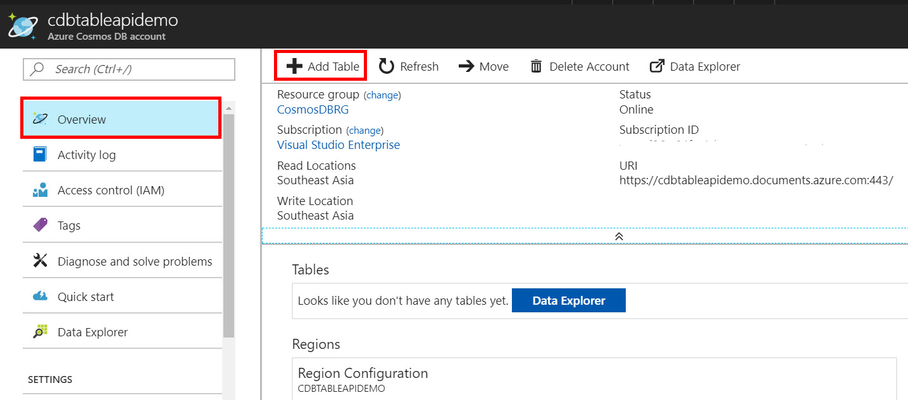

**Step 5:** Enter Table Details

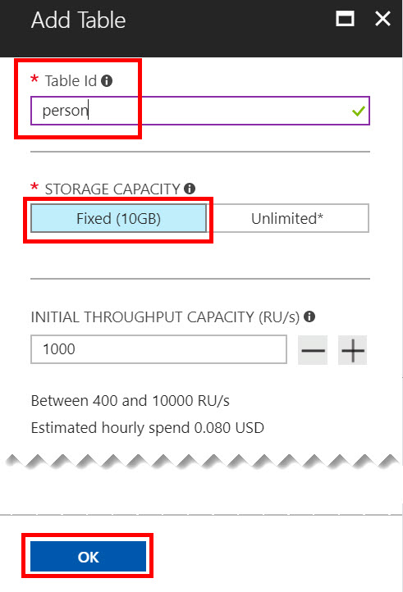

**Table Id:** Enter table name

Ex. person

**Storage Capacity:** Fixed (10GB) or Unlimited

Ex. Fixed (10GB)

**Initial Throughput Capacity (RU/s):** 1000

Wait for few seconds to create table with person name.

Click on table name

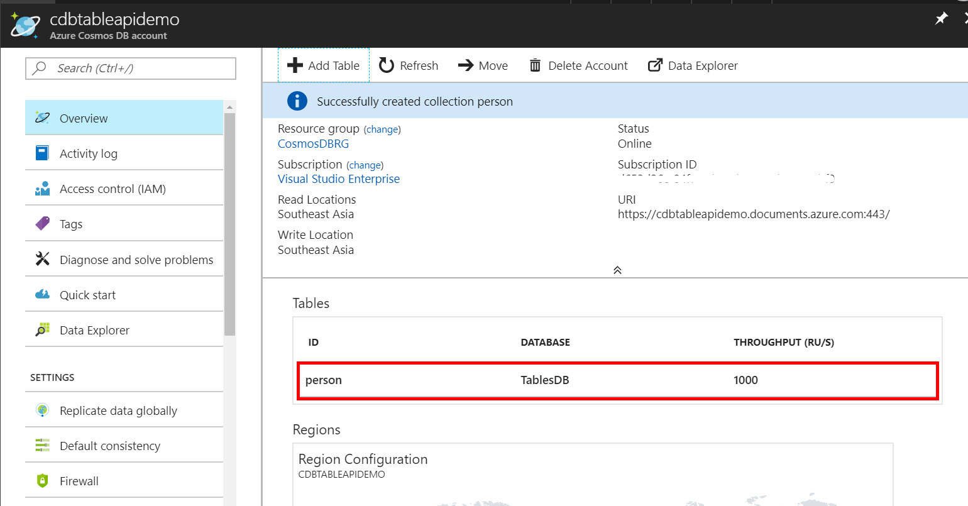

**Step 6:** After selecting table name it will open Data Explorer blade.

TableDB -> person table, Entities, Scale & Settings option available.

Click on **Add Entity** option

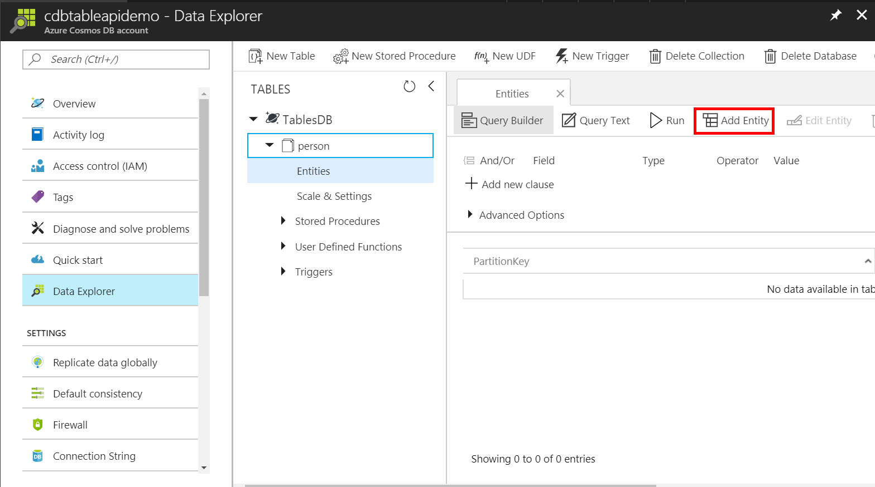

**Step 7:** Enter Table Entity Details such as below:

**PartitionKey:** Romil,

**RowKey:** Bheda

**City:** Bangalore

After entering all details click on **Add Entity** button

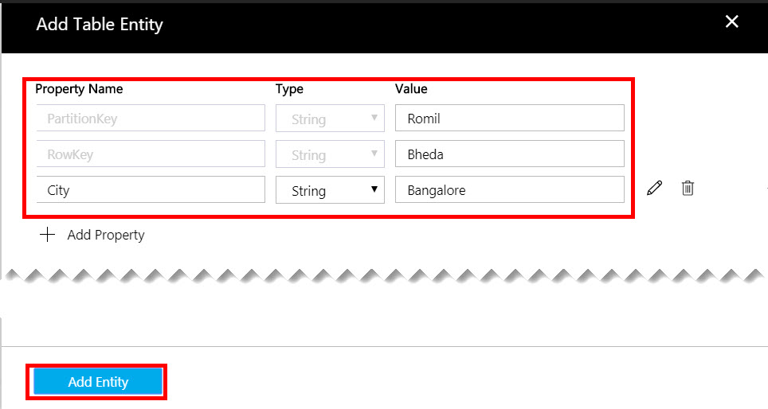

**Step 8:** One entity added successfully. One more time click on **Add Entity** button.

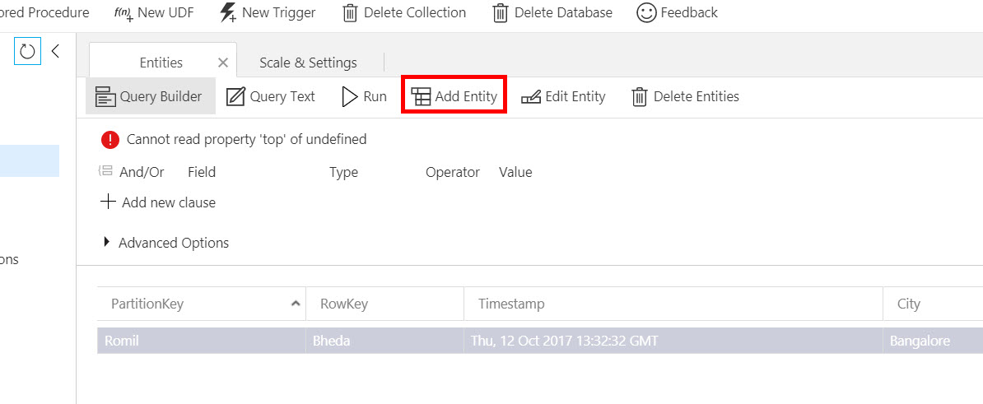

For second record we are adding more property.

**PartitionKey:** Suketu

**RowKey:** Nayak

**City:** New Delhi

**Mobile:** 9876543210

**Country:** India

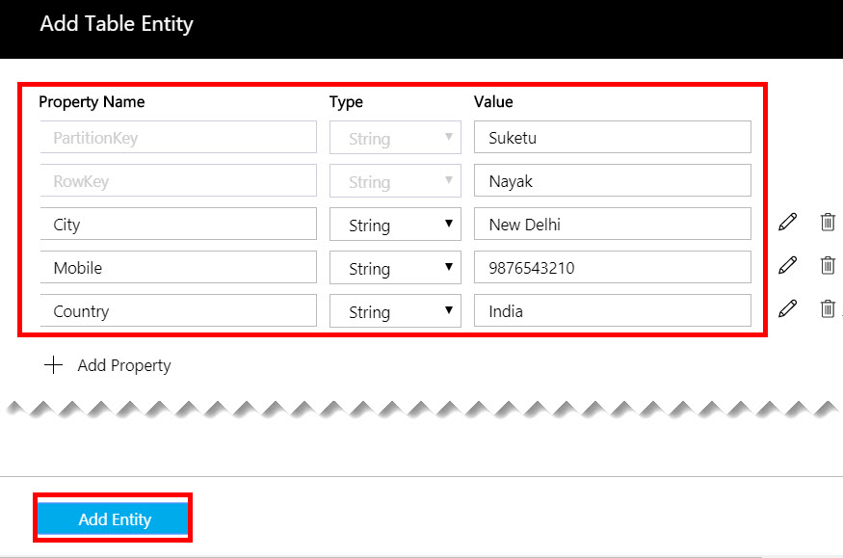

So, two entities listed below:

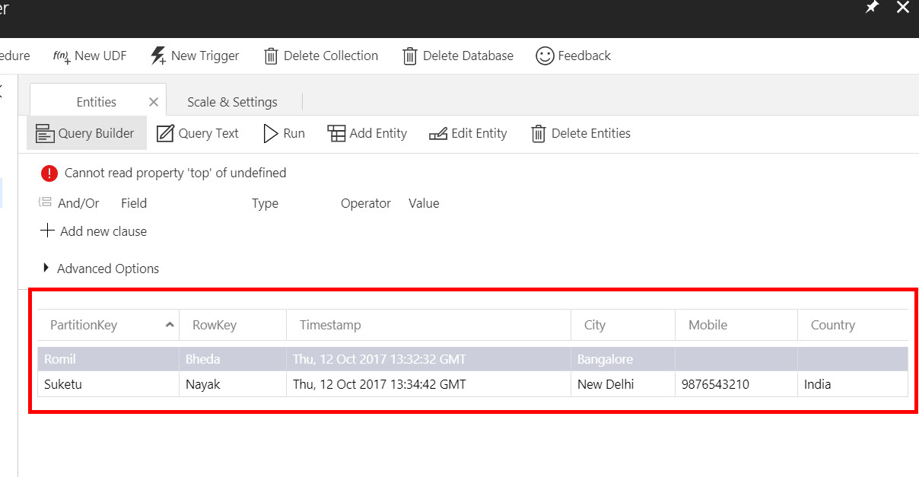

**Step 9:** Click on **+Add new clause** option

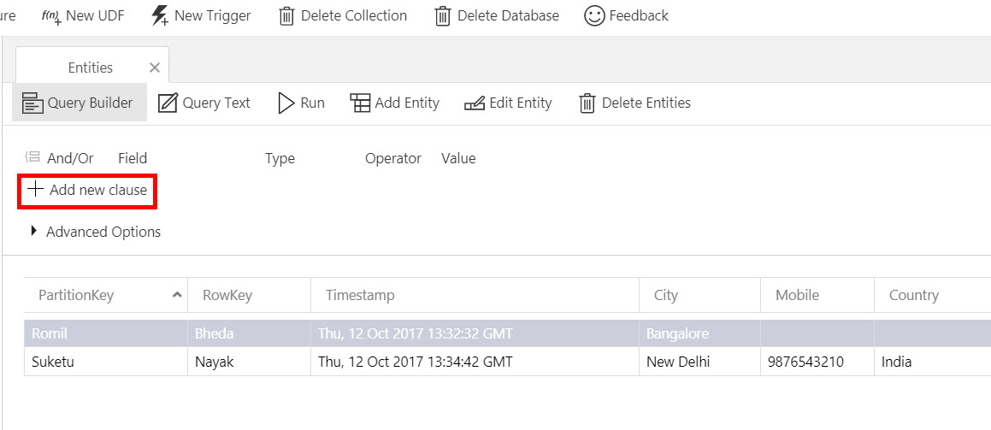

**Step 10:** Choose Field, Type, Operator, Value & click on **Run** button to get the result.

**Field:** PartitionKey

**Value:** Romil

Click on **Run** button & result will load.

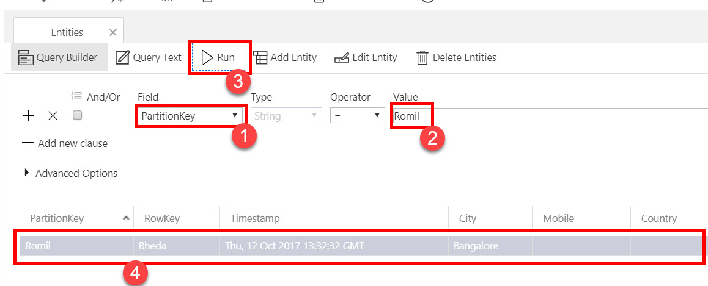

**Step 11:** Now again adding one newer clause for further query

Ex. **And/ Or:** Or

**Field:** Country

**Type:** String

**Operator:** =

**Value:** India

Click on **Run** button & result will load.

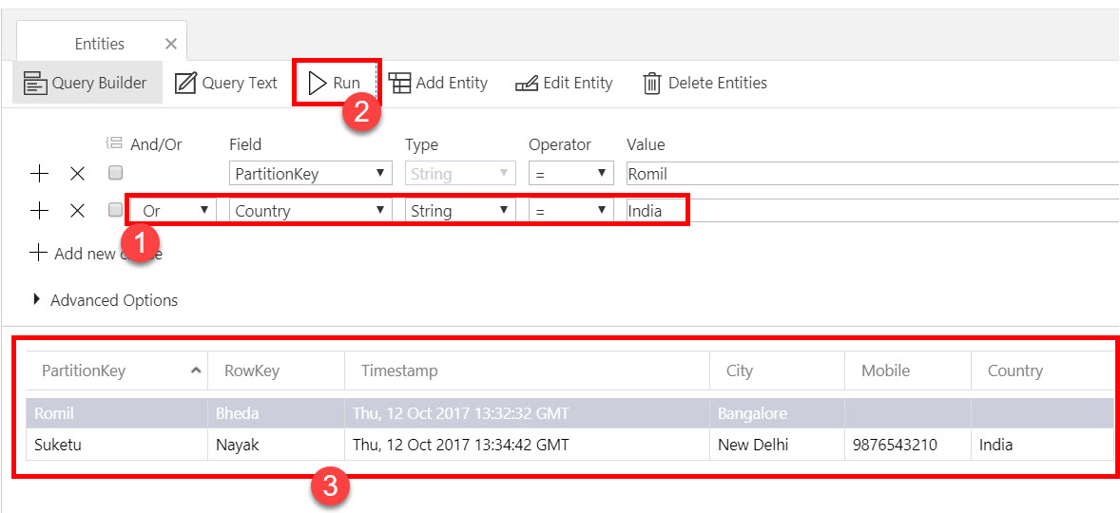

**Step 12:** **Query Text** option also available where you can check query

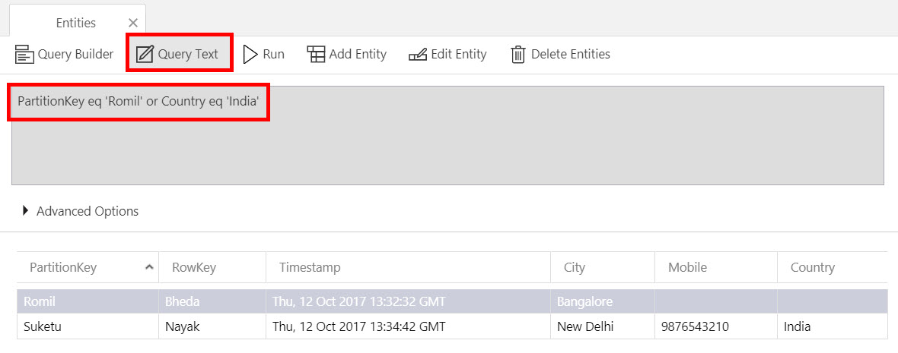

**Step 13:** Select **Scale & Settings** option & right side **Estimated hourly cost** available

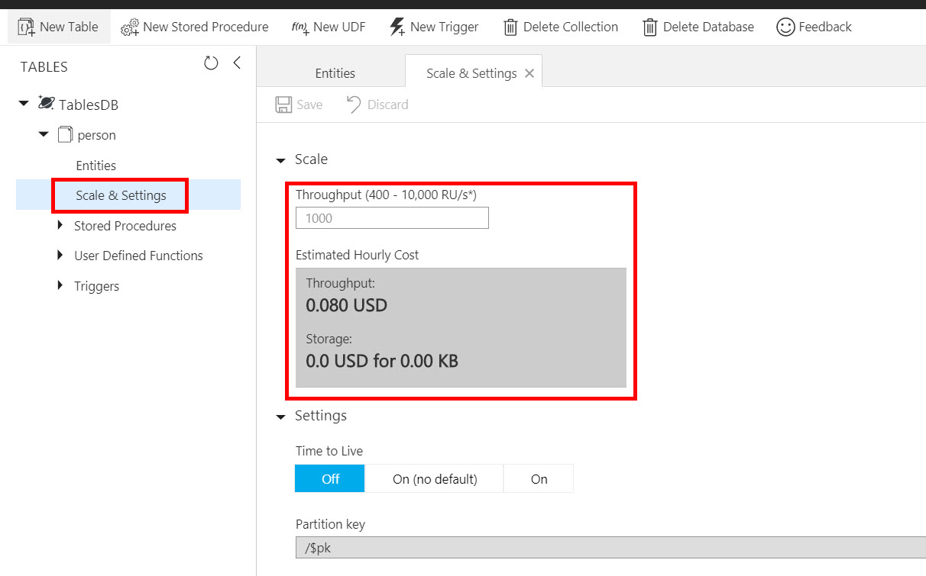

Try to change Throughput to 500 & Estimated Hourly Cost will update as below:

